List of Contents

1. Introduction and Objectives: Page No.

* Introduction 3
* Objectives
* Specific Purposes
* Document Conventions 4
* Intended Audience 5

2. Identification of need 6

* Problem Statement 6
* Proposed System 6

3. System Analysis 7

* Data Collection Tools 7
* Charting Tools 7
* Dictionary Tool 7
* Factors affecting Analysis 7
* New Improved System 8

4. Project Scope 9

5. Project Features 10

6. Project Entities 10

7. Software Requirement Specification (SRS) 11

* Hardware Interface 12
* Software Interface 12
* Communication Interfaces 13
* Design and Implementation Constraints 14
* User Documentation 15
* Functional Requirements 16
* Nonfunctional Requirements 16
* Performance Requirements 16
* Safety Requirements 17
* Security Requirements 18

8. Project Planning 19

* Spiral Model 19

9. Project Scheduling 20

* Gantt Chart 21

10. Project Design 24

* Data Flow Diagrams 25
* 0-Level DFD 26
* !-Level DFD 27
* 2-Level DFDs 29
* Entity-relationship Diagram(ER) 30
* Use Case Diagrams
* Use Case-1
* Use Case-2

11. Project Lifecycle (System Design) 33

* Project Perspective 34
* Modules of the project 35
* Description of modules 36

12. Database Design (Table Structures) 43

13. User Interface (Screenshots) 46

14. Project Testing 75

* Testing Techniques 75
* Testing Strategies 76

15. System Security measures 77

* Database Security 77

16. Conclusion 78

17. Future Scope 79

18. Bibliography 80

Introduction

Recycling Is An Integral Part Of Any Waste Management System As It Represents A Key Utilization Alternative To Reuse And Energy Recovery (Waste-To-Energy). Which Option Is Ultimately Chosen Depends On The Quality, Purity And The Market Situation.

The Quality Requirements For Waste Materials Range From Reuse To Energy Recovery. Reuse Requires A Minimum Functionality That Reconditioning Can Be Accomplished Within Certain Cost And Time Limits. Recycling Only Requires A Single Material Waste Stream Of High Purity (Source Collection) And A WET Facility Is Able To Process Any Waste For Energy Recovery As Long As It Is Not Contaminated With Hazardous Substances.

To Meet These Requirements The Different Waste Streams (E.G., Municipal Solid Waste, Industrial Waste, Pharmaceutical Waste, Etc.)Must Be Treated Differently. A Waste Management System Of A Municipality, County, Etc. Separates And Controls The Different Waste Streams According To The Available Treatment Options In This Certain Region. However, The Rise Or Fall Of A Waste Management System Highly Depends On The Support Of The Residents And Employees. They Take The First Step In A Long Chain Of Processes By Separating Their Waste Stream In Direct Reusable Or Recyclable Waste Streams (E.G., Paper, Plastics, Glass, Etc.) And Waste That Can Be Used As A Fuel For Energy Recovery.

Document Conventions

Font family -Headings: Andalus

-Body: Andalus

Font size -Heading: 48

-Sub Heading: 20 and 36

-Body: 18

Font color -Heading: Black

-Content: Black

Intended Audience

## The different audience to this SRS is as follows:

## Developer

## Developer uses this SRS to maintain and modify the project accordingly.

## Client

## The client uses this SRS to verify the predefined requirement and suggest further changes.

## Tester

## Tester performs Black-Box or White-Box testing according to pre-defined requisites provided in SRS.

## Analyst

## Analyst uses this document for analysis of the proposed system as required by the client.

# Identification of Need

The basic aim of problem statement analysis is to obtain a clear understanding of the needs of the Client, what exactly is desired from the software, and what the constraints on the solution should be.

**Problem Statement**

The following major problems were come across during requirement analysis of the project under study:

* Tedious process of finding accurate results to searches.
* Long wait to receive answers to user’s queries.
* Code provided in very long time,thus requirement not fulfilled in time constraint.
* Unreliable people provide codes which may or may not get executed.
* Browsing for programming material is a dull and boring task.
* Proper feedback mechanism is not available from users to the coders.

# Proposed System

Keeping the limitations of existing system in mind, various changes have been made to modify the behavior of the new and improved system.

The proposed system shall be :

* Easy to use
* A user friendly interface facilitates its effectiveness.

The proposed system focuses on the following changes:

* Common platform for accessing information regarding different languages according to the different users domain.
* Communication between users,to develop a user friendly environment.
* Providing answers to the queries in as short time as possible.
* Conduction of events and other interesting activities by employees meant for this purpose only.
* Enhance the experience of browsing a programming based site.
* Providing means for feedback between users and coders.
* Queries of the users can be answered by multiple users in case the user wants more opinions.

## System Analysis

System Analysis and Design is the main phase of the Software Development Life Cycle. It can be said that it is the heart of any System. Such an analysis needs expert supervision and the person who works as a System Analyst, should possess minimum experience of 2 to 3 years. One can use Analysis Tools to analyze the system.

Some of the tools we have used to analyze the problem are given below:

## Data Collection Tools

We have collected the information regarding the current system & procedures, which are going on. These collections help us to understand the old systems know how. Some such tools are Observation, Group Discussions and Case Studies.

## Charting Tool

The Graphical Representation of System under consideration helps to understand the minor problems and the flow of information very easily, which can become very helpful in analysis as well as to generate the new and improved System requirements. Graphical Information is better to understand as compared to the textual information as it is more vivid and expressive. Such diagrammatic representation includes E-R Diagram, Use case Diagrams and Data Flow Diagrams to collect all the information and in building the relationship among the various entities of the project.

## Dictionary Tool

## This tool helps to maintain the record of data and description of the System elements that have been used in the project through the Data Items, Processes and Data Stores. In short, it is the met data ,i.e,data about the data.

Factors affecting Analysis

After the use of tools, we have to analysis of a system through main four factors:

#### Capacity:

First of all we have to collect the information of current system, through which we can enumerate the limitations and work on them.

#### Equipment:

Secondly we have to collect the information about hardware requirements for the development.

#### Space:

This piece of information can be useful when we have to collect the information about storage space for existing system and expected storage after proposed system gets developed.

#### Procedure:

The study about which type of procedures are going onis useful to analyze whether all procedures are doing well or if there is a need for change in approach.

New Improved System

Increase Capability :

We have decided to increase the capability of the proposed system, as it is the basis of growth of any organization. Keeping this point of view in mind, we have suggested the management to add more employees, to manage the activities of the website, making it more active, better equipment’s to be used and add other resources to the system which increase the magnitude of work that can be achieved.

#### Lower the Expectation :

We have suggested to initially,reduce the performance requirement by changing the time for the start of a task & compilation of a task.

#### Redefine Nature of task :

We have suggested changing some of the activities through shifting the responsibilities; also we have suggested adjusting levels of specialization and generalization and altering performance standards.

#### Control :

We have also analyzed the working control system. We have collected the loopholes of the system & guided the seniors to design some mechanism to increase the likelihood that activities are carried out properly and that unexpected events are detected & handled as expected.

## Project Scope

The main scope of study will be as follows:

* It should perform all programming-related searches and provide relevant answers.
* It should provide a Login and Registration System to Users.
* It should contain all the information of Users, Events and Event Managers who are registered in this site.
* It should process and evaluate requests submitted by users.
* It should provide Users the facility of creating and updating their personal accounts.
* It should provide the Users an Interactive platform for Query Management.
* It should have Administrator as the Final Authority for verification of login, events and maintenance.
* It should maintain an online collection of eBooks by renowned writers for User Reference.

It should contain all the information of Event Managers like Personal Details, Professional Details and Previous Events Organized Details.

* It should contain all Event-related details like event name, event manager in charge, duration of event registration etc.
* It should inform Users and Event Managers about an event that is going to be conducted shortly.
* It should display updated events and site-related news.
* It should allow feedback, rating and suggestions by Users.
* It should contain information related to request expiry or re-registration.

Project Features:

It has features of providing all the information online (through the Internet) about the programming codes, Users, Events and Event Managers.

* The UWMis a special purpose web site.
* The site includes the keyword searches and query management which gives the visitors as well as users an easy way to find out or request the related codes as per their requirements.
* The site acts as a middle-ware for the Expert Users and reputed IT firms by bridging the gap between them through it.
* The site lets Event Managers organize exciting events from time to time for Users.
* The site includes other socially interactive features within itself like-:
* News
* Articles
* Feedback and Rating

Project Entities

On the basis of requirements, the project can be classified into **four** major categories of users-:

* **Administrator:** Owner who takes care of maintenance of the website.
* **Visitor:** Who only searches codes and other information available on the website?
* **Event Manager:** Employee who organizes events and announces winners.
* **Users:** The visitors who register and become users can ask queries, give responses and participate in events and other interactions on the website.

# Software Requirement Specifications

# (SRS)

Hardware Interface

**Server:**

Processor : 1 .6 (GHz) Pentium processor

RAM : 1 GB

HDD : 80GB

Display : DirectX 9-capable video card running at 1024 x 768 or higher display resolution

**Client:**

Processor : P3 866 MHz or later

RAM : 512 MB

HDD : 2GB

Display : 1024 x 768 High colour

**Developer:**

Processor : 1 .6 (GHz) Pentium processor

RAM : 2 GB

HDD : 40GB

Display : DirectX 9-capable video card running at 1024 x 768 or higher display resolution

Software Interface

**Server**

Browser : Internet Explorer 9 or other

Database : MS SQL

Web server : Apache Server

Operating

System : Windows, Linux

**Client**

Browser : IE 10 or other Latest browser

Operating

System : Any O.S. Windows/Linux/Solaris

**Developer**

Browser : IE 9 or any browser

IDE : Notepad++

Database : MS SQL

OS : Windows 8 /Windows 7

Documentation

Tool : MS-Word, MS-PowerPoint

Designing tool : Dreamweaver , Notepad ++

Scripting language : JavaScript,jQuery, Ajax

## 

## Communication Interfaces

# Communication standards that will be used are-:

## HTTP, HTTPS and WWW

# HTTP- Hyper Text Transfer Protocol.

# HTTPS (HTTP+SSL) – Hyper Text Transfer Protocol Secure + Secure Socket Layer

# WWW - World Wide Web

## Design and Implementation Constraints

* Minimum 1 GB RAM is required at the server side.
* Minimum 1.6 Ghz Processor is required at the server side.
* Minimum 512 MB RAM is required at the client side.
* JavaScript and Query are used as client side scripting languages andC# as server side scripting language as they provide better compatibility with .NET Platform.

## User Documentation

Online Help-

It Provides assistance to the end user about the flow of the system as well as enhances the understandability of the proposed system.

# Manual-

# We also provide manuals to facilitate the end user to handle over heading.

# 

# Nonfunctional Requirements

# Performance Requirements

* System availability of 24x7 hours.
* All .aspx user forms should be Ajax enabled.
* Both client side and server side validations should be there.

## Safety Requirements

* Password will be stored in encrypted form in database,

Even admin also will not be able to know the users details.

* Password will be used.
* MD5 algorithm will be used.

## Security Requirements

* Only registered Users can post queries on portal.
* Any offensive comments will be Reported and thereby removed, timely.
* Illegal forums are periodically viewed and managed.
* Users not accessing there accounts are sent notice of expiry or re-registration.

Project Planning

The key to a successful project is in the planning. Creating a project plan is the first thing we should do when undertaking any kind of project.

Often project planning is ignored in favor of getting on with the work. However, many people fail to realize the value of a project plan in saving time, money and many other problems.

Following are the steps involving planning -:

1. Understand the project goals.

2. List the things that need to be delivered as the end result of project goals completion.

3. Schedule each task required to fulfill each goal.

4. Project Supporting plans.

Once the planning begins, there is need of a Software development Model whose approach can be used to design the project on a whole. Deciding the best model depends upon the kind of project that is being developed.

This project has been developed using the Spiral Model.

**SPIRAL MODEL**

In 1988, Barry Boehm proposed a comprehensive life cycle model called Spiral Model.This model of development combines the features of the prototyping and the waterfall model. The spiral model is intended for large, expensive and complicated projects.

The spiral model combines the idea of iterative development (prototyping) with the systematic, controlled aspects of the waterfall model. It allows for incremental releases of the product, or incremental refinement through each time around the spiral. The spiral model also explicitly includes risk management within software development. Identifying major risks, both technical and managerial, and determining how to lessen the risk helps keep the software development process under control.

Starting at the centre, each turn around the spiral goes through several task regions **:**

**•** Determine the objectives, alternatives, and constraints on the new iteration.

• Evaluate alternatives and identify and resolve risk issues.

• Develop and verify the product for this iteration.

• Plan the next iteration



**Spiral Model**

Project Scheduling

Knowing the amount of time a team has to complete a project makes it easier for the project manager to allocate tasks and get things done. Therefore, many project managers rely on project schedules to set timeframe parameters for projects.

**Features**

Project scheduling looks at which tasks need to be performed for a project and assigns deadlines for their completion. The project scheduler sets these deadlines by calculating how long each task should take to perform. Scheduling requires a comprehensive understanding of which action steps need to get done and when.

**Function**

Implementation teams use project schedules as charted timelines to stay on track with deadlines. Projects consist of a series of tasks and each task is given its own deadline. If various departments or teams are working on a project, each group may be given its own schedule to follow for its part of the project.

**Types**

The three most common types of project schedules, according to Bright Hub are-:

* + **Master schedules** are general summaries of the overall project, from start to finish.
  + **Milestone schedules** list all of the project's significant events, and are often presented to senior managers so that they can see the project's progress.
  + **Detailed project schedules** are the most operational of the three, breaking down all of the activities, tasks and action steps that need completing.

**Effects**

Project managers and investors are interested in project scheduling for budgetary reasons. When money is budgeted for the implementation team, it is important to monitor whether the project will be on time or not. Projects that do not meet deadlines may cost more for resources and staff wages.

GanttChart

**Gantt chart** is a type of bar chart, developed by Henry Gantt in the 1910s, that illustrates a project schedule. Gantt charts illustrate the start and finish dates of the terminal elements and summary elements of a project. Terminal elements and summary elements comprise the work breakdown structure of the project.

Some Gantt charts also show the dependency (i.e. precedence network) relationships between activities. Gantt charts can be used to show current schedule status using percent-complete shadings and a vertical "TODAY" line as well.

Although now regarded as a common charting technique, Gantt charts were considered revolutionary when first introduced. In recognition of Henry Gantt's contributions, the Henry Laurence Gantt Medal is awarded for distinguished achievement in management and in community service. This chart is also used in information technology to represent data that has been collected.

**Gantt Chart**

Project Design

System Design is the most intricate and lucrative phase of the Software Development Life Cycle. It has major impact on the later phases, particularly testing and maintenance. The output of this phase is the design document. This document is similar to the blueprint or plan for any solution.

The design activity is often divided into two phases:

1: System Design

2: Detailed Design

#### System Design

System Design aims to identify the modules that should be in the system, the specifications of these modules and how they interact with each other to produce the desired results. At the end of system design, all the major data structures, file formats and major modules in the system and their specifications are decided.

#### Detailed Design

During Detailed Design, the internal logic of each of the modules specified in System Design is decided. During this phase further details

of the data structures and algorithmic design of each of the modules is specified. The logic of modules is usually specified in high-level design description language, which is independent of the target language, in which the software will eventually be implemented.

Data Flow Diagrams (DFDs)

Data Flow Diagrams (DFD), also known as bubble chart, is used for the purpose of clarifying system requirements and identifying the major transformation that will become program in system design, so it is a starting point of the designing phase that functionally decomposes the requirements specification down to the lower level of details. A Data Flow Diagram consists of series of bubbles joined by lines. The bubbles represent the data transformation and the line represents the data flow in the system.

**Defining DFD Components**: - DFDs consist of four basic components that illustrate how data flows in a system:

**1.Entity**: - An entity is the source or destination of data. Entities either provide data to the system (referred to as a source) or receive data from it (referred to as a sink). Entities are often represented as rectangles (a diagonal line across the right-hand corner means that this entity is represented somewhere else in the DFD). Entities are also referred to as agents, terminators, or source/sink.

**2.Process**: - The process is the manipulation or work that transforms data, performing computations, making decisions (logic flow), or directing data flows based on business rules. In other words, a process receives input and generates some output. Process names (simple verbs and dataflow names, such as “Submit Payment” or “Get Invoice”) usually describe the transformation, which can be performed by people or machines. Processes can be drawn as circles or a segmented rectangle on a DFD, and include a process name and process number.

**3.Data Store**: - A data store is where a process stores data between processes for later retrieval by that same process or another one. Files and tables are considered data stores. Data store names (plural) are simple but meaningful, such as “customers,” “orders,” and “products.” Data stores are usually drawn as a rectangle with the right- hand side missing and labelled by the name of the data storage area it represents, though different notations do exist.

**4.Data Flow**: - Data flow is the movement of data between the entity, the process, and the data store. Data flow portrays the interface between the components of the DFD. The flow of data in a DFD is named to reflect the nature of the data used (these names should also be unique within a specific DFD). Data flow is represented by an arrow, where the arrow is annotated with the data name.

**Data Flow Diagram Symbols**

There are four types of symbols that are used to design DFD.

SQUARE:

A Square defines a source and the destination of the system Data.

ARROW:

An Arrow identifies the Data Flow.

CIRCLE or BUBBLE:

A Circle or Bubble represents the process that transforms incoming Data Flow into outgoing Data Flow.

**OR**

OPEN RECTANGLE:

It represents Data Storage.

**OR**

Zero-level DFD

1-Level DFD

2-Level DFDs

2-Level DFDs

Entity Relationship Diagram(ER )

An Entity Relationship Diagram (ERD) is a visual representation of different data using conventions that describe how these data are related to each other.

**E-R Diagram Symbols & Notations:**

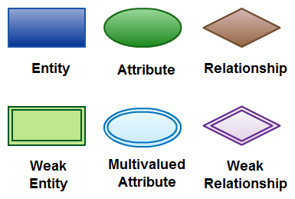

There are three basic elements in an ER Diagram: **entity, attribute,relationship**.

**Entity: -**An entity can be a person, place, event, or object that is relevant to a given system. For example, a school system may include students, teachers, major courses, subjects, fees, and other items.Entities are represented in ER diagrams by a rectangle and named using singular nouns.

* **Weak Entity: -**A weak entity is an entity that depends on the existence of another entity.It uses a foreign key combined with its attribute to form the primary key.

**Attribute: -**An attribute is a property, trait, or characteristic of an entity, relationship, or another attribute. Meanwhile, attributes can also have their own specific attributes.

* **Multi valued Attribute: -** If an attribute can have more than one value it is called an multi valued attribute.
* **Derived Attribute: -** An attribute based on another attribute. This is found rarely in ER diagrams. For example for a circle the area can be derived from the radius.

**Relationship: -**A relationship describes how entities interact. For example, the entity “carpenter” may be related to the entity “table” by the relationship “builds” or “makes”. Relationships are represented by diamond shapes and are labelled using verbs.

# Project Lifecycle

**(System Design)**

Product Perspective

## Combination of 9 modules:

## Different modules interact with each other to facilitate communication via message sending and information sharing.

## A user may have to visit different portals for different types of codes, which becomes a hectic process. This website provides every component in a compact and integrated environment.

## 

# Modules

# of the Project

The Project can be divided into the following Modules :

* Search Code Management.
* Registration Management.
* Query and Answers.
* Suggestions, Feedback and Rating.
* Event Management.
* Article Management.
* Administration.
* User Management.
* News Management.

**DESCRIPTION OF MODULES**

**Module 1:**

**Search Code Management Module**, which is further sub-divided into following sections:-

* **Visitors’ End:**
* Query/Code Search
* Search for Highly Rated Users.
* Search for Article of the Week.
* News Search.
* Event Search.
* **Users’ End:**
* Search for EBooks.
* Search for Article of the week.
* Search for other Users’ Profile.
* News Search.
* Event Search
* **Event Manager’s End:**
* Search for Suggested Events.
* Search for Users who can participate in Upcoming Event.
* Previous Events Search.
* Search for Article of the Week.
* News Search.

**Module 2:**

**Registration ManagementModule**, which is further sub-divided into following sections:

* Visitor Registration Management.
* Administration Login.
* User Login.
* Event Manager Login.
* Forget User Name or Password.
* Change Password.

**Module 3:**

**Query and Answer Module**, which is further sub-divided into following sections:

* Submit Query.
* Answer Queries.
* Answer Modification.

**Module 4:**

**Suggestion , Feedback and Rating Module** which is further sub-divided into following sub-sections:

* User Feedback.
* User Rating.
* Event Suggestion by Users.
* Visitor Suggestion.

**Module 5:**

**Event Management Module** which is further sub-divided into following sections:

* Taking permission of Administrator for Organizing Event.
* Sending Invitation to Users.
* Form Questionnaires.
* Verify Answers.
* Announce and Post Winners on News Section.
* Inform Users and Post News of Upcoming Event.

**Module 6:**

**Article Module** which is further sub-divided into following sections:

* Article by Users.
* Article by Event Manager.

**Module 7:**

**Administration Module** which is further sub-divided into following sections:

* Login Verification.
* Event Confirmation.
* Verify Current Event Manager, Winners of Events held, and Upcoming Events.
* Deciding on User of the Month and Year on the basis of their Feedback, Rating and Events Organized by Event Manager.
* Deciding Article of the Week.
* News Management.

**Module 8:**

**User Management Module** which is further sub-divided into following sections:

* Profile Management -
* Users Profile.
* Event Manager’s Profile.
* User Interaction –
* Free Ebooks Management.
* Answer Modification.
* Discussion on Query among multiple users.
* Participation in events.
* Sharing information by posting articles.

**Module 9:**

**News Module** which is further sub-divided into following sections:

* **IT Industry News Management:**
* Post Updated News of IT Industry by Administrator and User.
* **Portal News Management:**
* Users Hired from Portal.
* Article of the Week.
* Announcing the Name of Current Event Manager by Administrator.
* Announcing Winners of Events held by Event Manager.
* Announce User of the Month and Year on the basis of their Feedback, Rating and Events Organized by Administrator.
* Post News of Upcoming Events by Event Manager.

**Database Design(Table structures)**

**Article_rating**

|  |  |  |  |
| --- | --- | --- | --- |
| Column Name | Data Type | Length | Constraint |
| id | int | 10 | Primary key |
| Article_id | int | 5 | Not null |
| rating | int | 5 | Not null |

**Articles**

|  |  |  |  |
| --- | --- | --- | --- |
| Column Name | Data Type | Length | Constraint |
| A_id | int | 10 | Primary key |
| Subject1 | varchar | 50 | Not null |
| body | varchar | MAX | Not null |

**Contact**

|  |  |  |  |
| --- | --- | --- | --- |
| Column Name | Data Type | Length | Constraint |
| Id | int | 10 | Primary key |
| Name | varchar | 20 | Not null |
| emailid | varchar | 35 | Not null |
| sub | varchar | 50 | Not null |
| Message1 | varchar | MAX | Not null |

**Ebooks**

|  |  |  |  |
| --- | --- | --- | --- |
| Column Name | Data Type | Length | Constraint |
| id | int | 10 | Primary key |
| Article_id | int | 5 | Not null |
| rating | int | 5 | Not null |

**Event Manager Details Table -:**

**empreg_details**

**Feedback**

|  |  |  |  |
| --- | --- | --- | --- |
| Column Name | Data Type | Length | Constraint |
| Name | int | 10 | Primary key |
| emailid | varchar | 35 | Not null |
| title | varchar | 30 | Not null |
| feedback | varchar | MAX | Not null |
| rating | int | 10 | Not null |

**User Interface(Screenshots)**

Home Page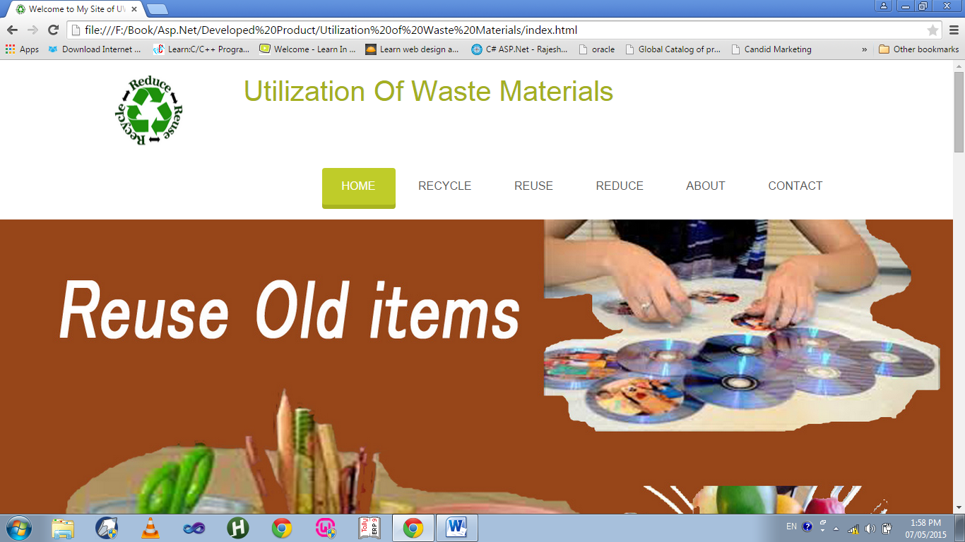

About Us

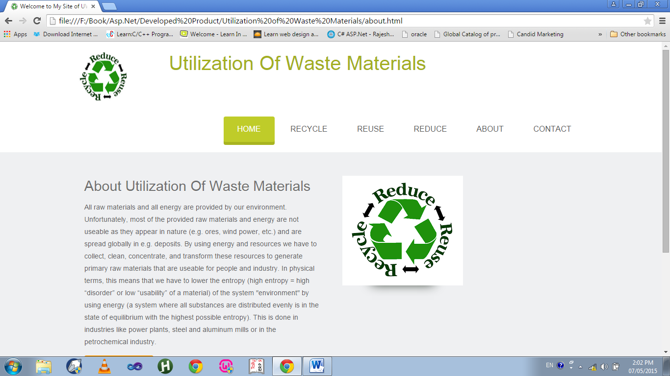

Recycle

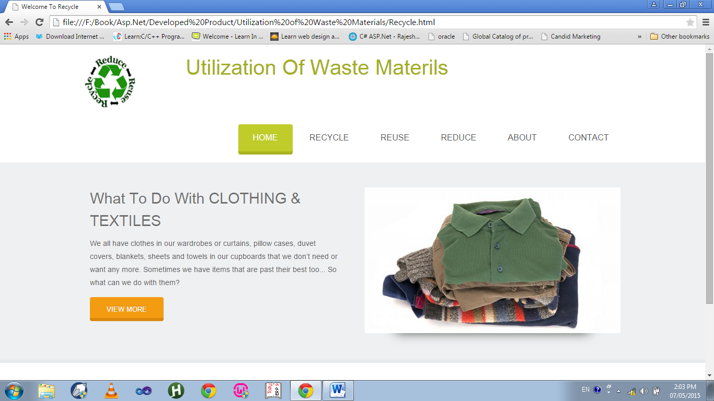

Reuse

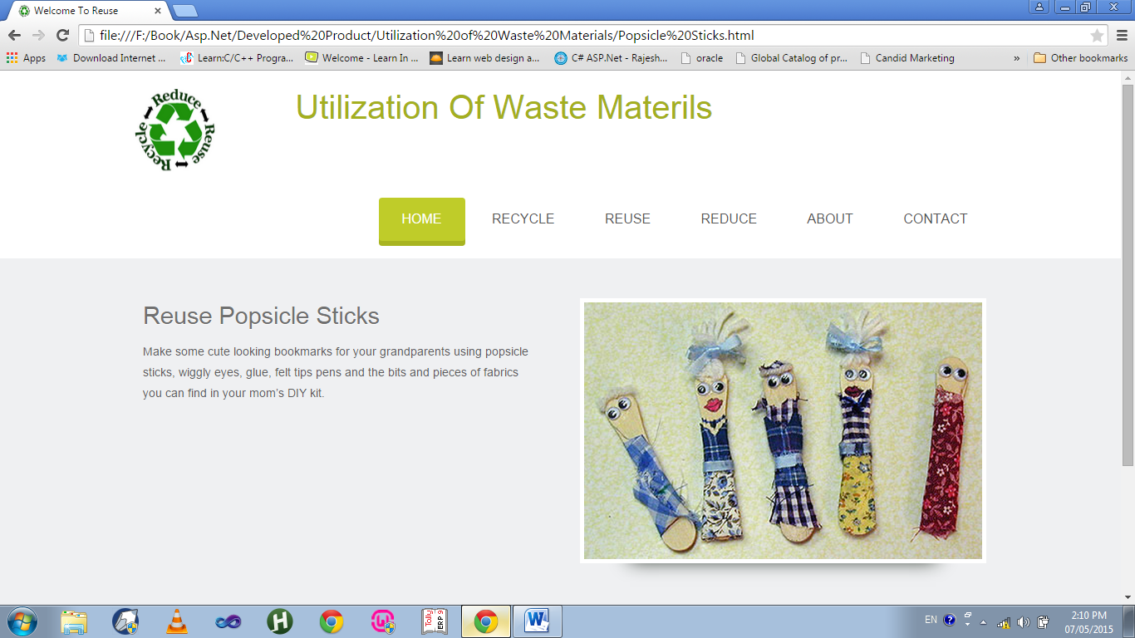

Reduce

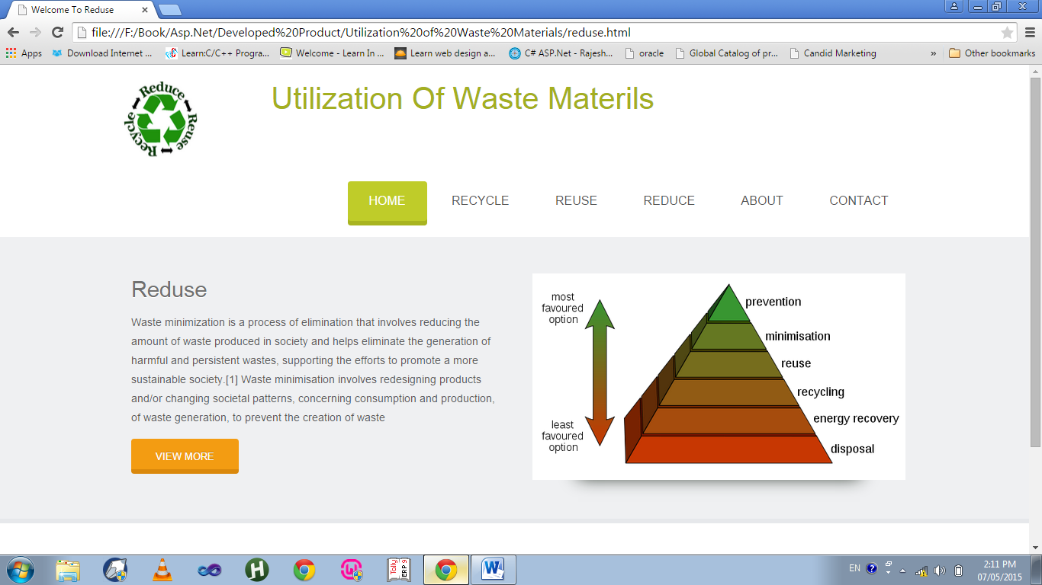

About

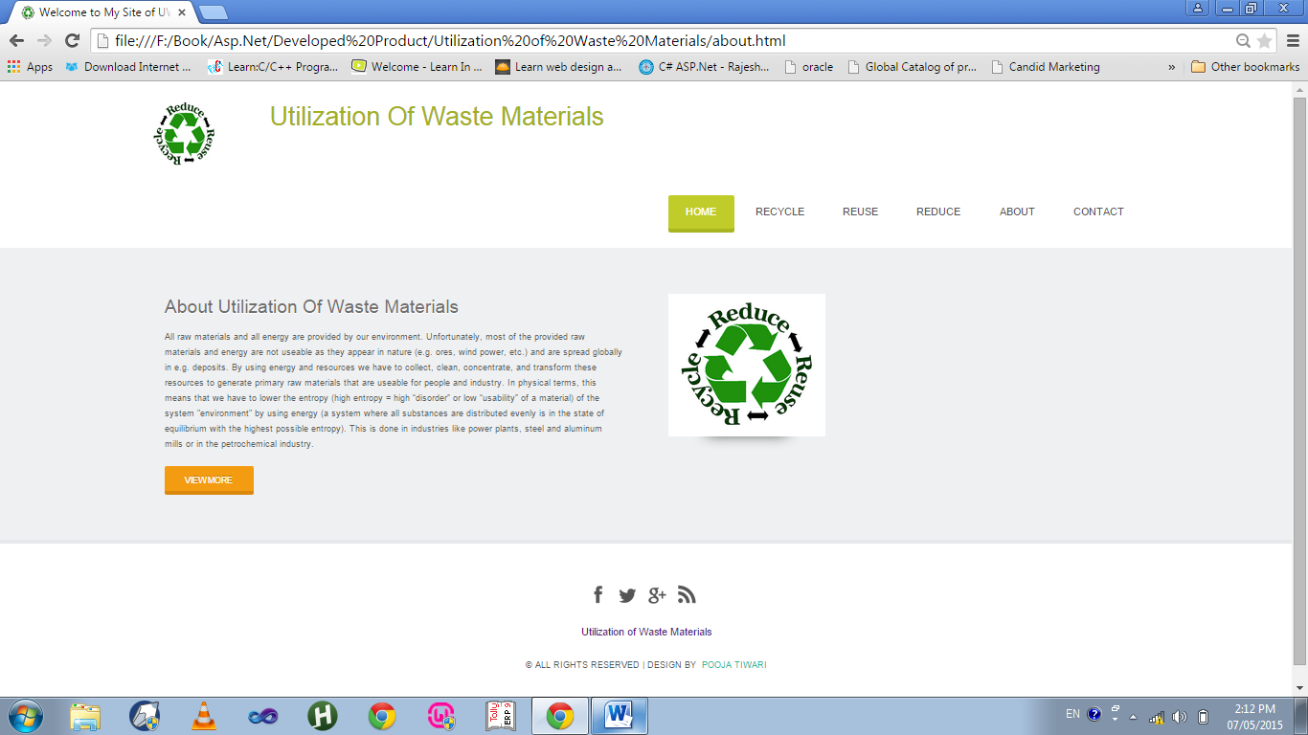

Contact Us

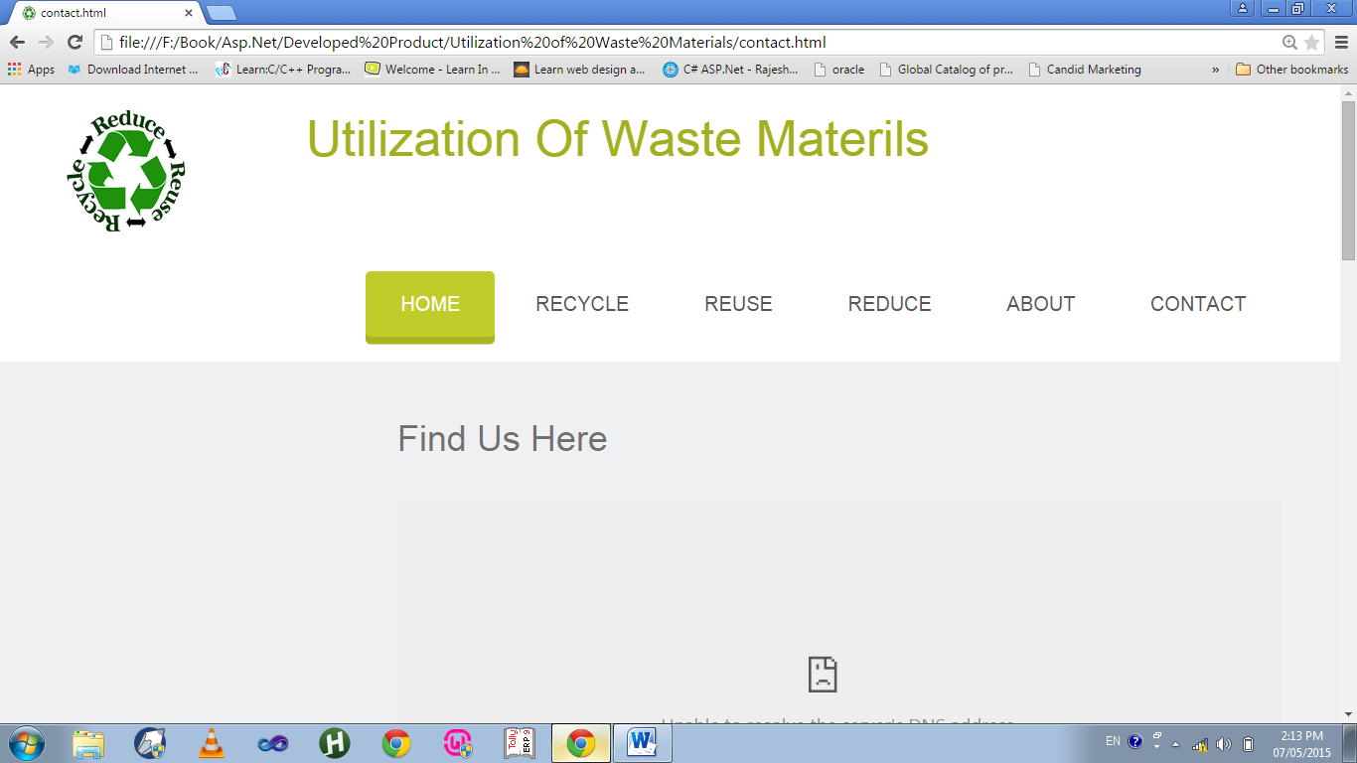

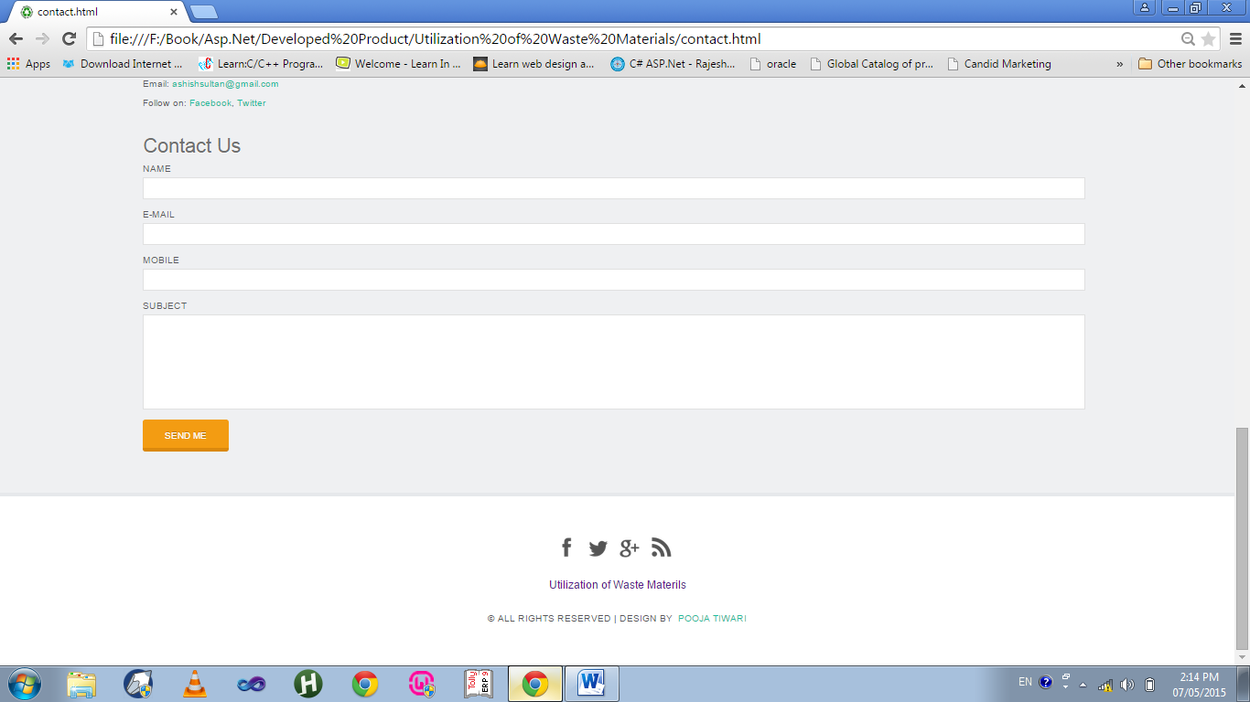

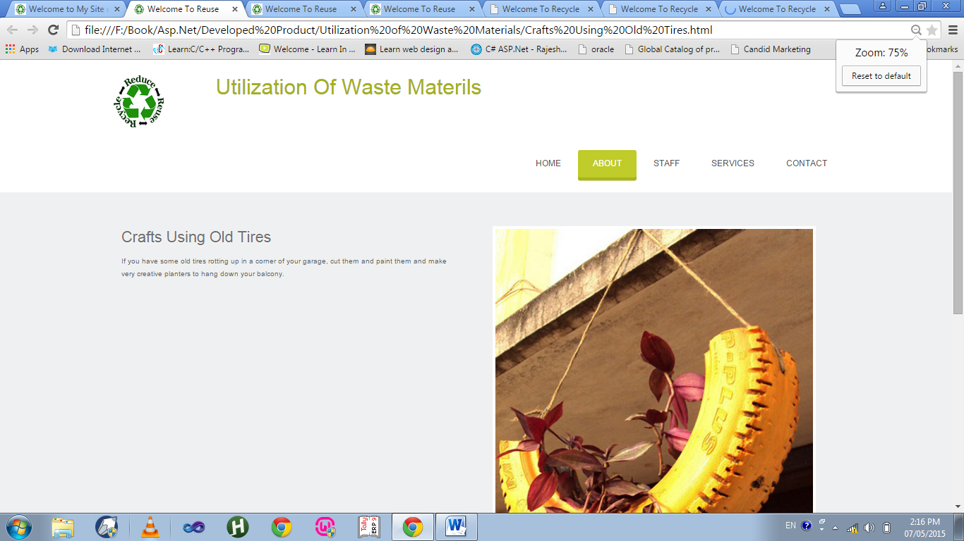

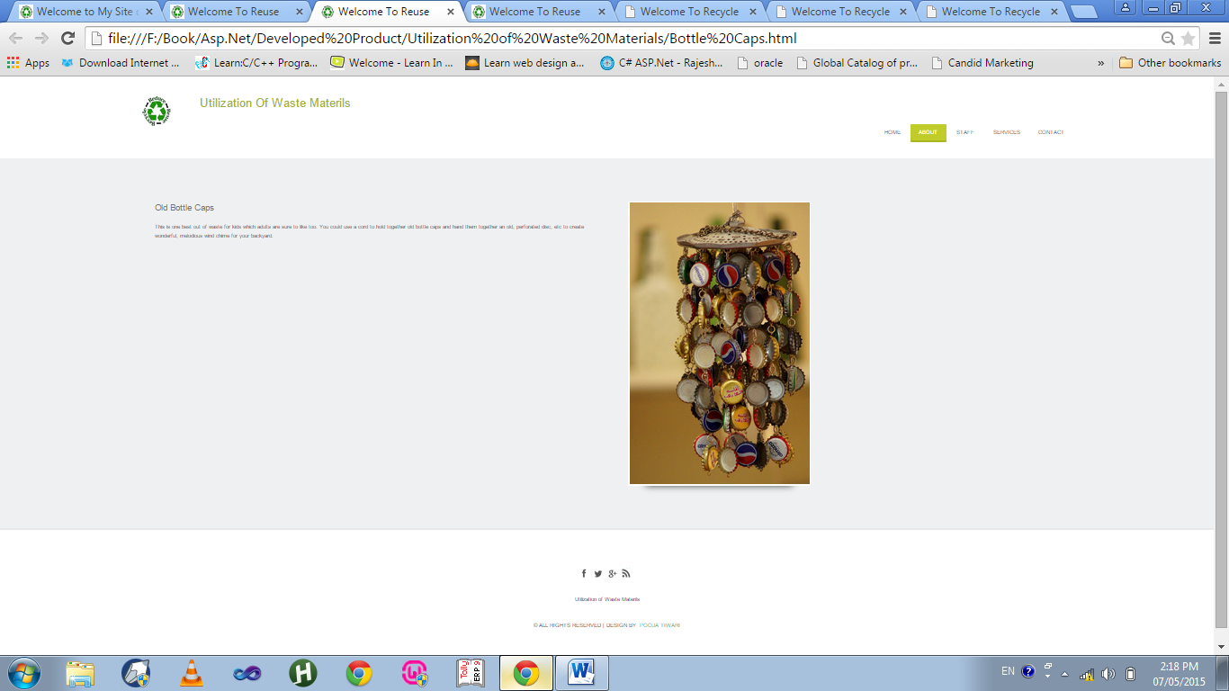

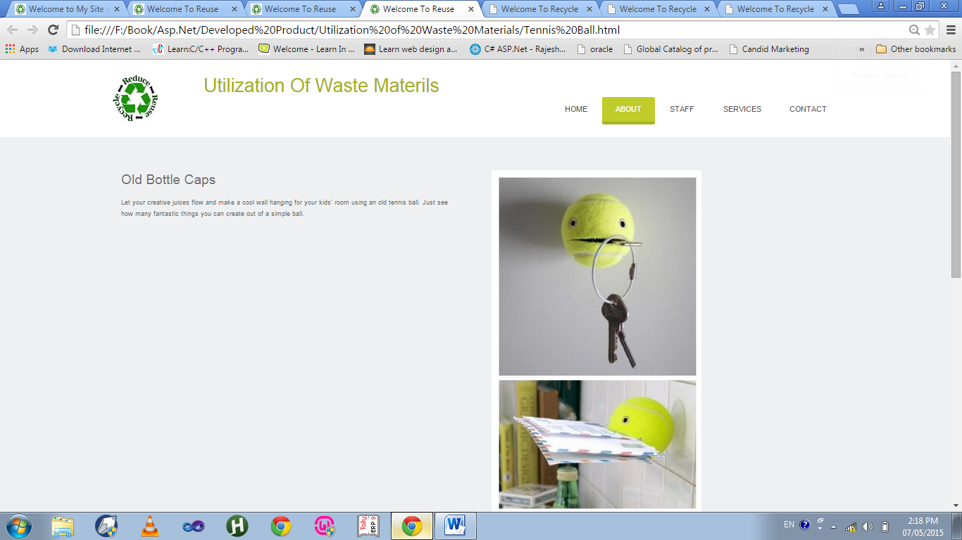

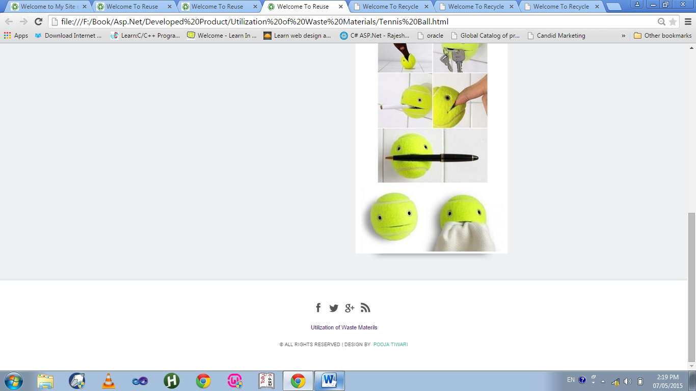

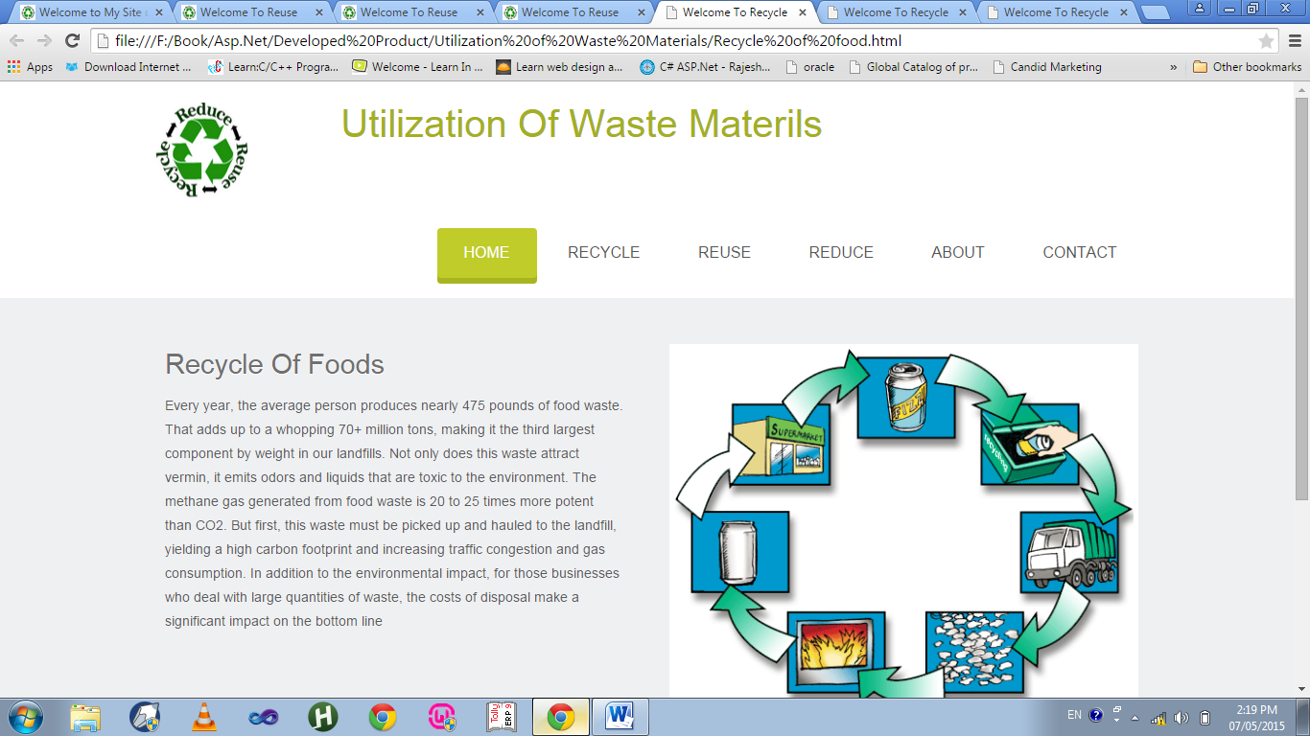

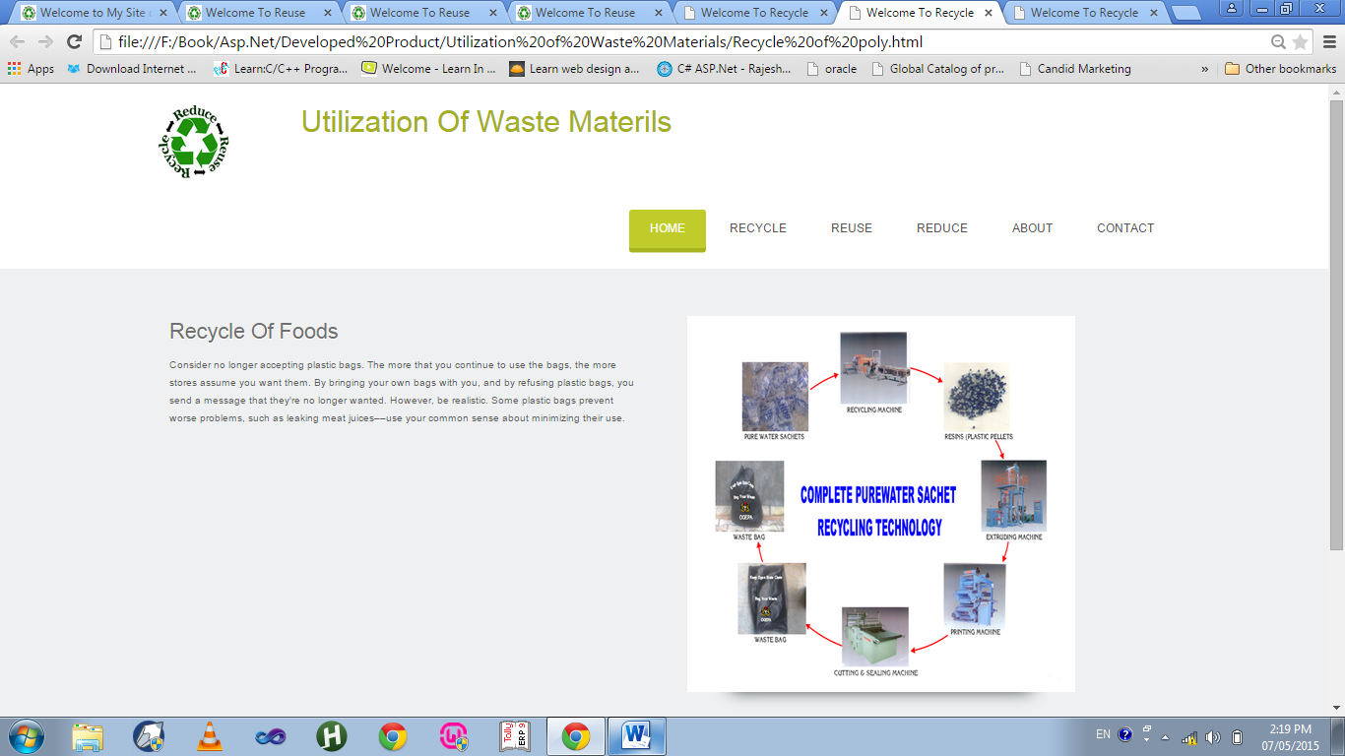

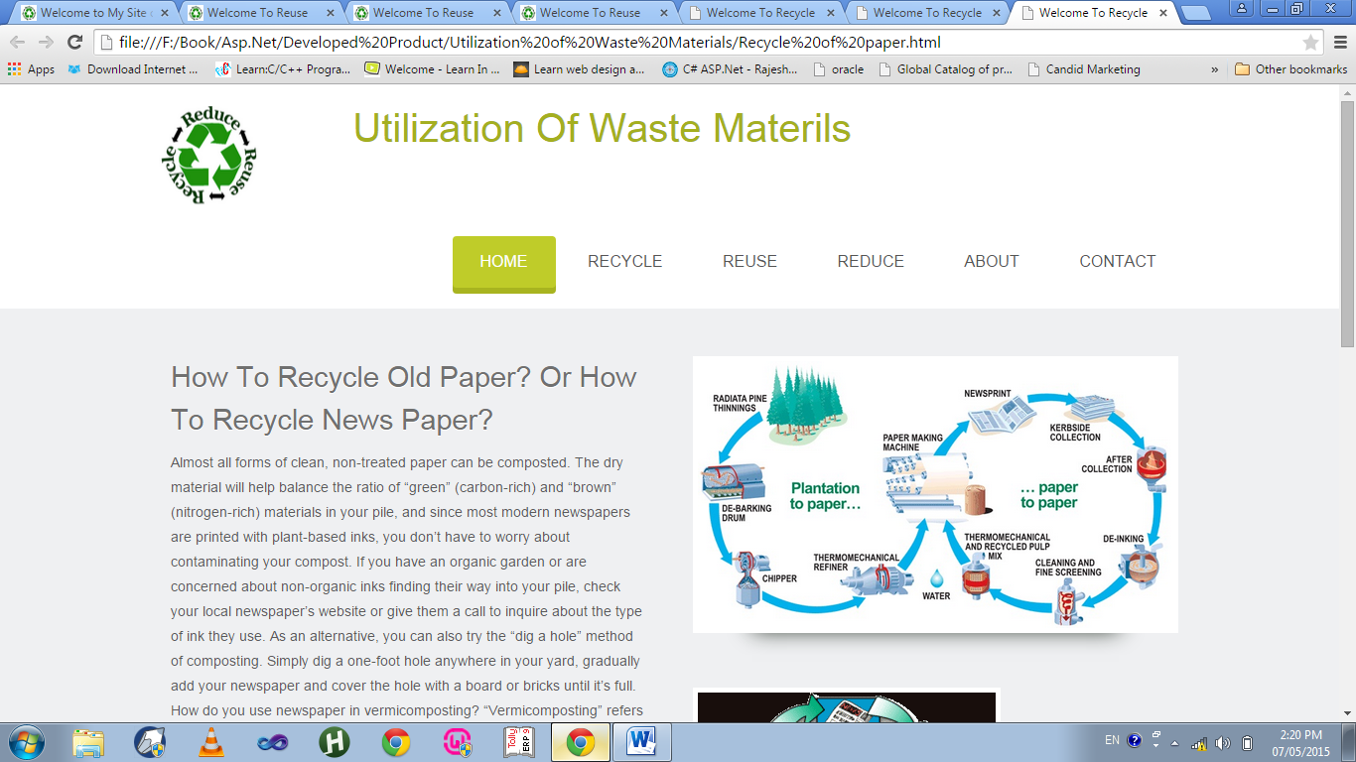

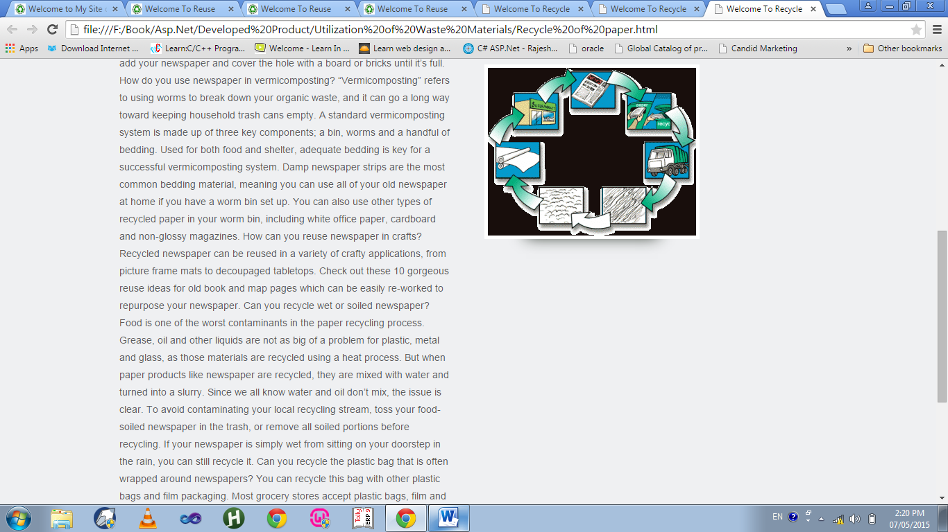

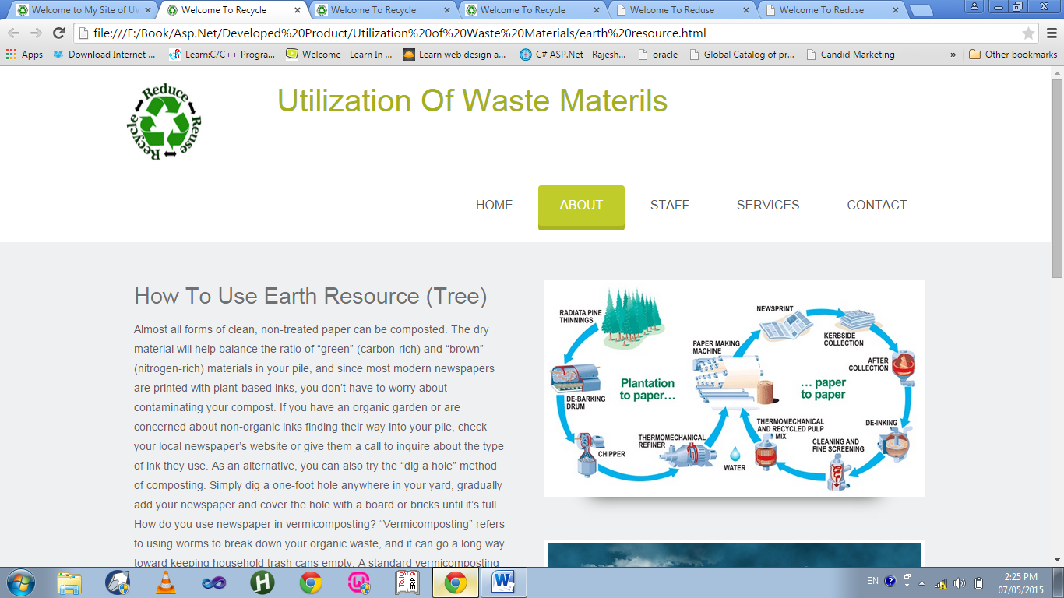

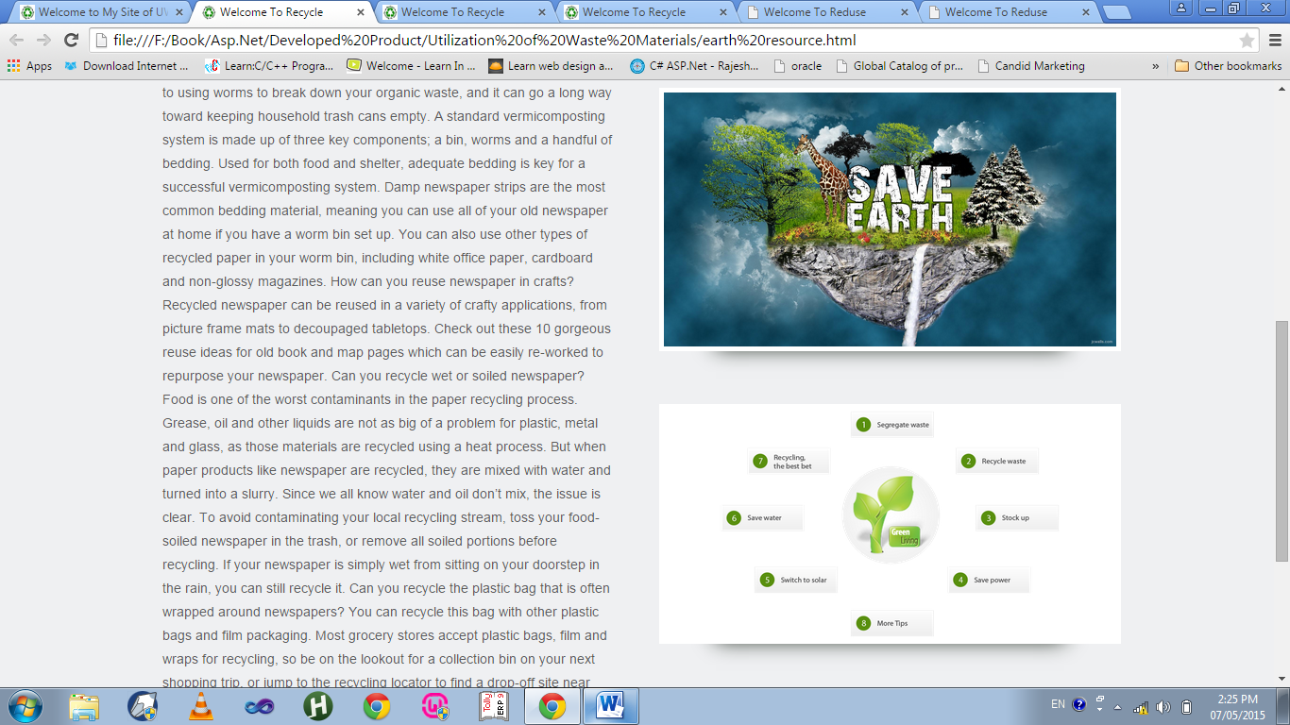

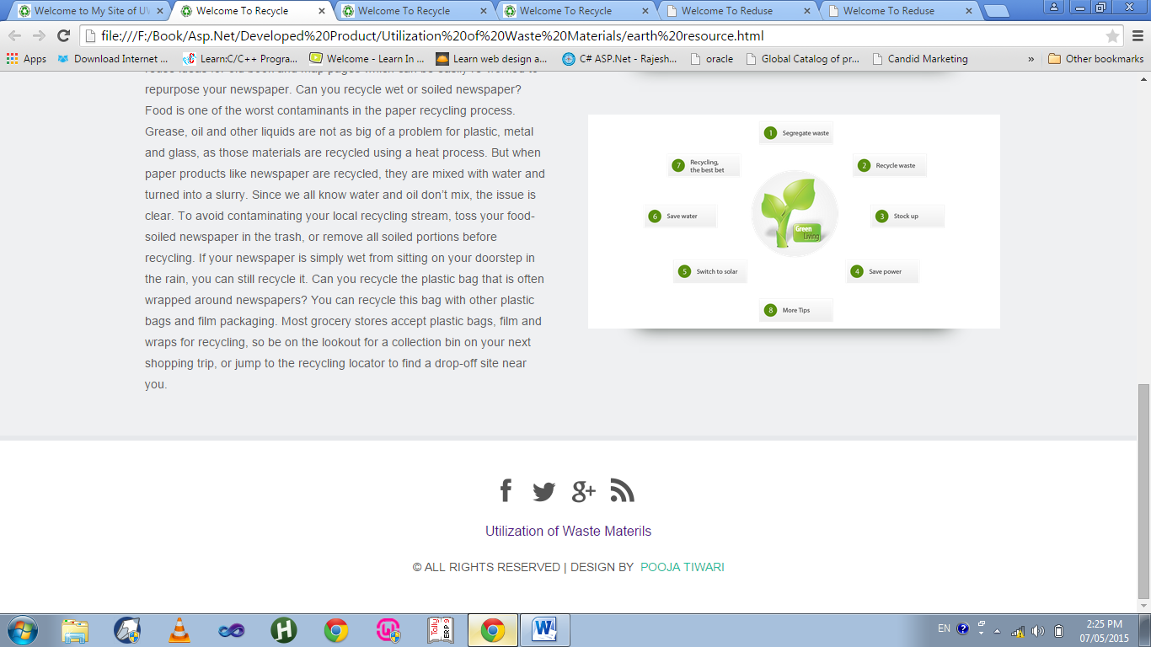

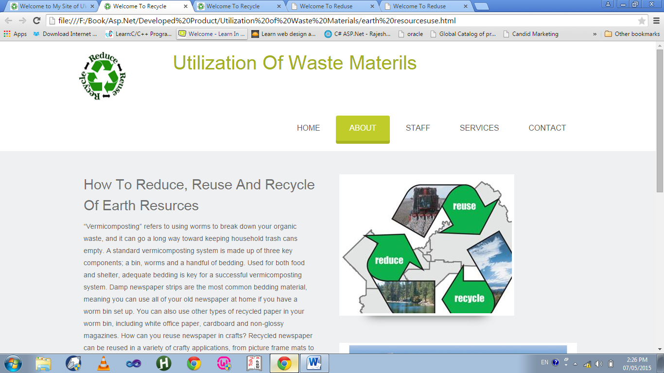

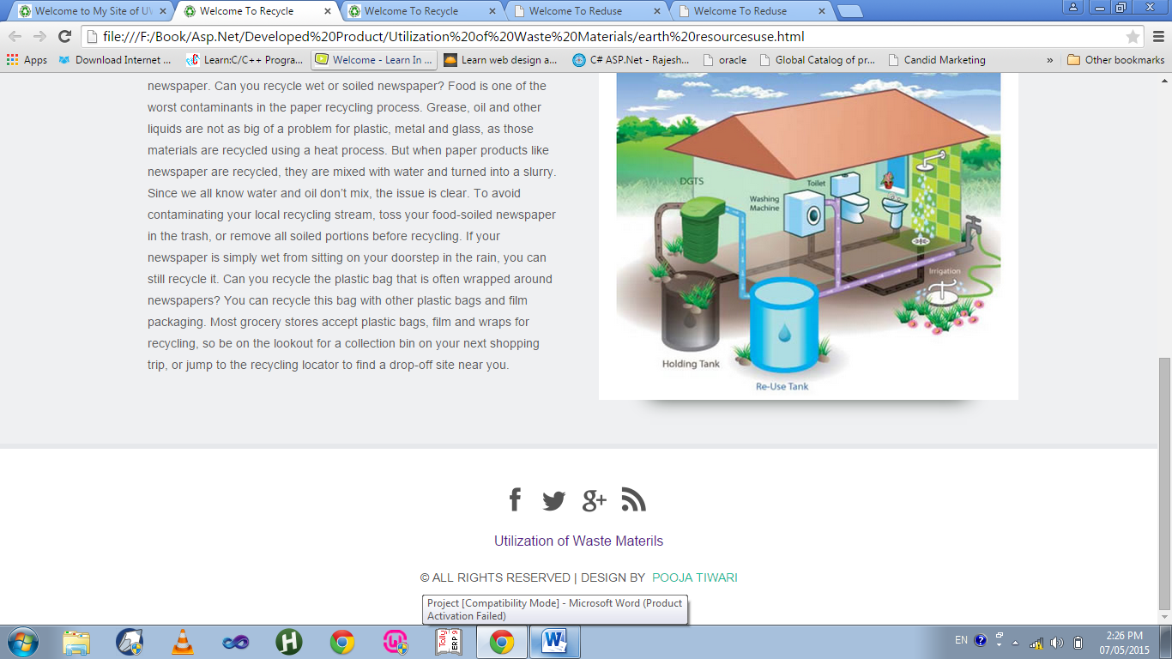

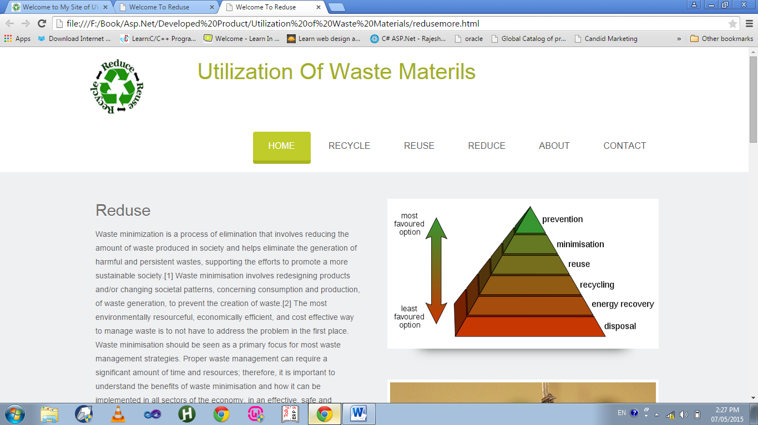

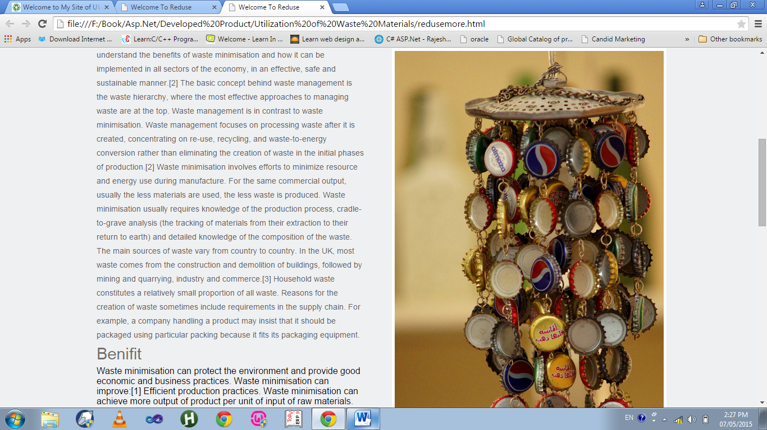

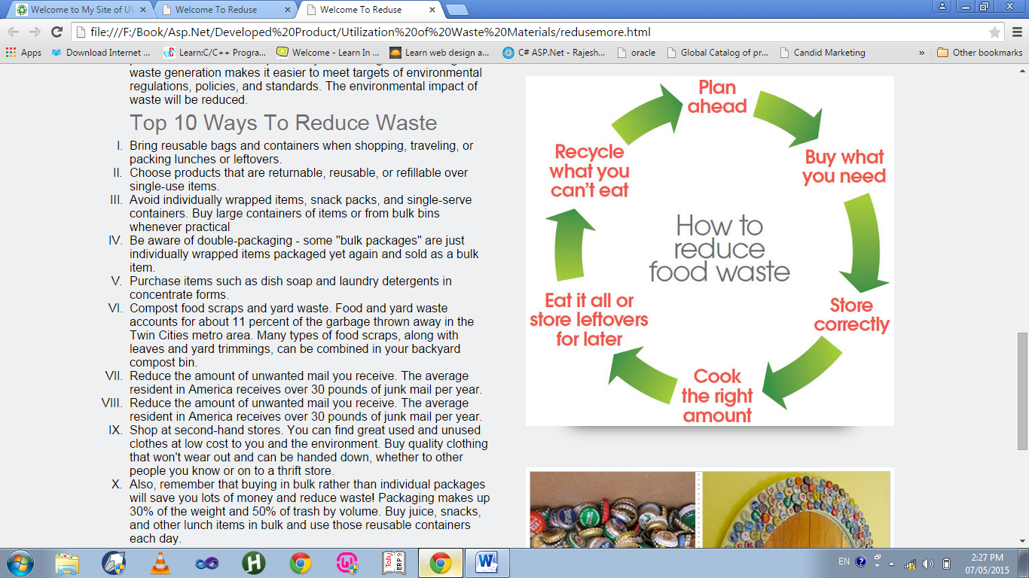

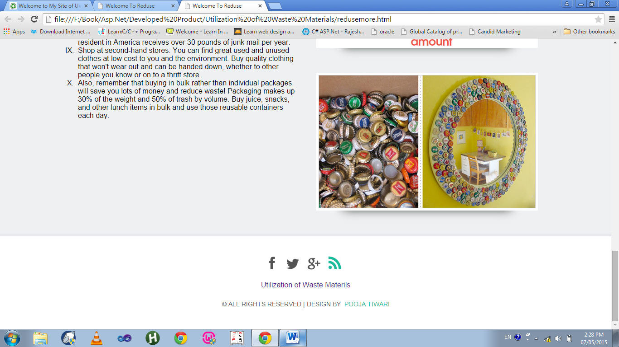

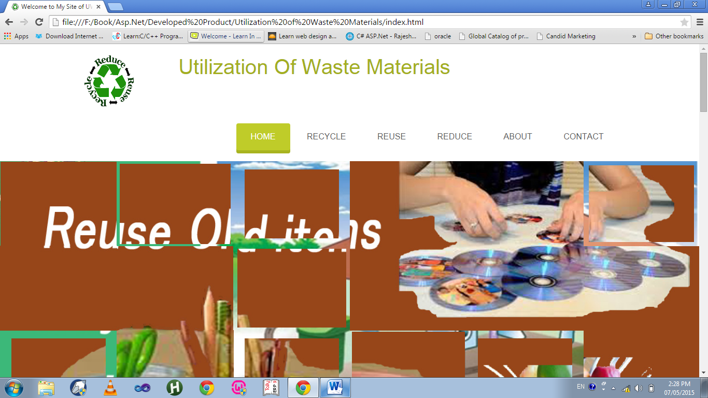

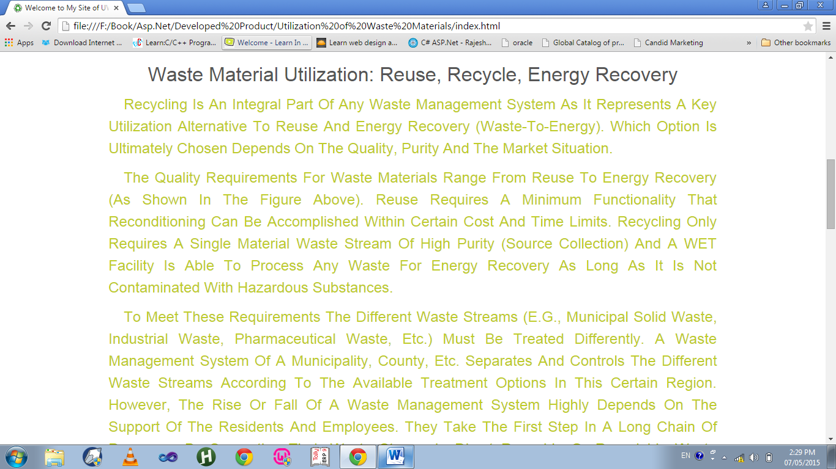

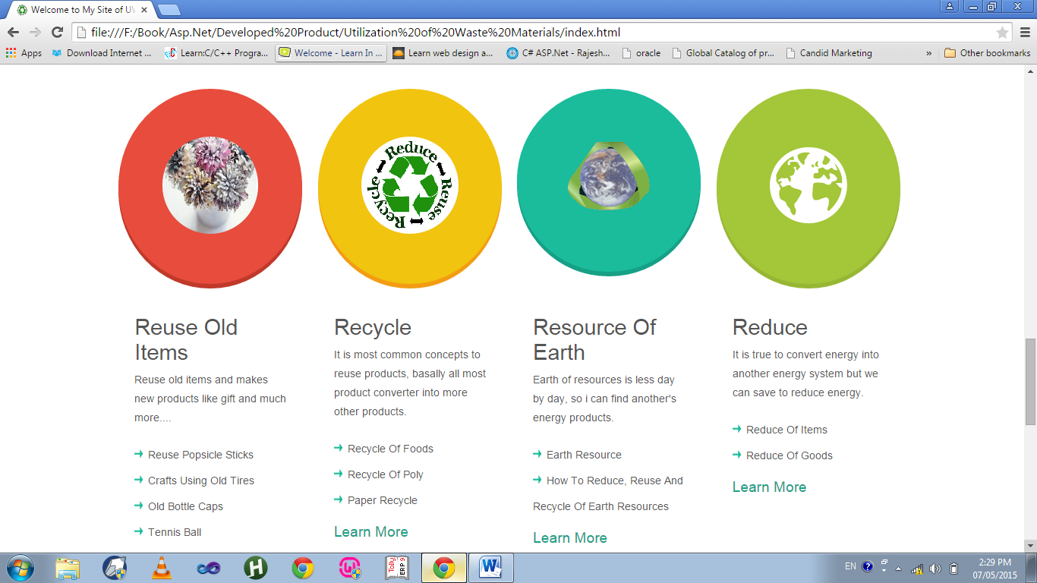

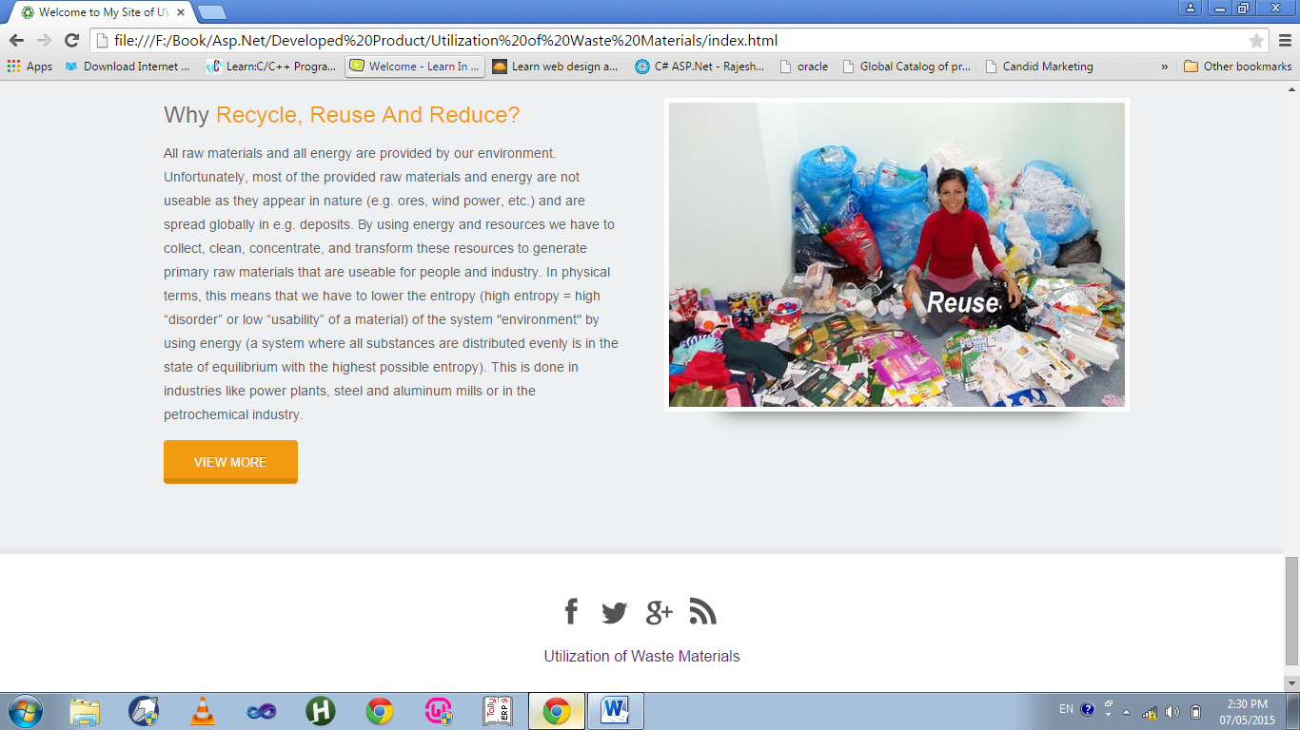

Project Testing

**Testing is a process of executing a program with the goal of finding errors**. So, testing means that one inspects behaviour of a program on a finite set of test cases (a set of inputs, execution preconditions, and expected outcomes developed for a particular objective, such as to exercise a particular program path or to verify compliance with a specific requirement, for which valued inputs always exist.

In practice, **the whole set of test cases is considered as infinite**, therefore theoretically there are too many test cases even for the simplest programs. In this case, testing could require months and months to execute.

So, how to select the most proper set of test cases?

Various techniques are used for that, and some of them are correlated with risk analysis, while others with test engineering expertise.

Testing is an activity performed for evaluating software quality and for improving it. Hence**, the goal of testing is systematic detection of different classes of errors** (error can be defined as a human action that produces an incorrect result, in a minimum amount of time and with a minimum amount of effort.

**TESTING TECHNIQUES:**

A testing technique specifies the strategy used in testing to select input test cases and analyze test results. Different techniques reveal different quality aspects of a software system, and there are two major categories of testing techniques, functional and structural.

**Functional Testing:** The software program or system under test is viewed as a **“black box”.** The selection of test cases for functional testing is based on the requirement or design specification of the software entity under test. **Functional testing emphasizes on the external behaviour of the software entity.**

.

**Structural Testing:** The software entity is viewed as a **“white box”.** The selection of test cases is based on the implementation of the software entity. The goal of selecting such test cases is to cause the execution of specific spots in the software entity, such as specific statements, program branches or paths. The expected results are evaluated on a set of coverage criteria. Examples of coverage criteria include path coverage, branch coverage, and data-flow coverage. **Structural testing emphasizes on the internal structure of the software entity.**

**TESTING STRATEGIES:**

### Unit testing

Unit testing, also known as **component testing** refers to tests that verify the functionality of a specific section of code, usually at the function level. In an object-oriented environment, this is usually at the class level, and the minimal unit tests include the constructors and destructors.

Unit testing alone cannot verify the functionality of a piece of software, but rather is used to assure that the building blocks the software uses work independently of each other.

### Integration testing

Integration testing is any type of software testing that seeks to verify the interfaces between components against a software design. Software components may be integrated in an iterative way or all together ("big bang"). Normally the former is considered a better practice since it allows interface issues to be localized more quickly and fixed.

Integration testing works to expose defects in the interfaces and interaction between integrated components (modules). Progressively larger groups of tested software components corresponding to elements of the architectural design are integrated and tested until the software works as a system.

### System testing

**System testing** of software or hardware is testing conducted on a complete, integrated system to evaluate the system's compliance with its specified requirements. System testing falls within the scope of black box testing, and as such, should require no knowledge of the inner design of the code or logic.

The purpose of integration testing is to detect any inconsistencies between the software units that are integrated together . System testing is a more limited type of testing.

System testing tests not only the design, but also the behavior and even the believed expectations of the customer.

### Acceptance testing

**Acceptance testing** is a test conducted to determine if the requirements of a specification or contract are met. It may involve chemical tests, physical tests, or performance tests.

In systems engineering it may involve black-box testing performed on a system (for example: a piece of software, lots of manufactured mechanical parts, or batches of chemical products) prior to its delivery.

Software developers often distinguish acceptance testing by the system provider from acceptance testing by the customer (the user or client) prior to accepting transfer of ownership.

System Security measures

**DATABASE SECURITY:**

Most Web sites need to selectively restrict access to some portions of the site.When a website stores its customers' credit card information in a database, for example, access to the database must be restricted. ASP.NET security features help you address this and many other security issues.

**ASP.NET, in conjunction with Microsoft Internet Information Services (IIS), can authenticate user credentials such as names and passwords** using any of the following authentication methods:

* Windows: Basic, digest, or Integrated Windows Authentication (NTLM or Kerberos).
* Microsoft Passport authentication
* Forms authentication
* Client Certificate authentication

Visual Studio.NET hides so many technical details behind the scenes that developers need only concentrate on the core business logic. However, hackers are on the lookout for any opportunity to hack into your application. Which means the pressure is on you to keep defense top of mind. If you don't, you'll quickly find your ASP.NET apps vulnerable to attack.

I have used few vital defences which will arm my website against the security threats.

The threats with the defences are mentioned below as follows:

**Cross-site Scripting**: Cross-site Scripting (XSS) happens when a hacker injects a script into your Web application (normally through user inputs) and your application accepts it without checking. When the data (containing the script) gets saved into your Web application, subsequent users may be affected as the script may inadvertently get loaded onto their Web browsers.

Fortunately, ASP.NET 4.5 ships with built-in request protection to detect inputs that contain scripts.

**Validating User Inputs:** The rule of thumb here is to assume the worst about your end users. They are bound to enter inputs that are totally unexpected. Be sure to check for illegal characters and limit the amount of data they can enter. ASP.NET ships with a lot of validation controls of which I havemade full use, both at the client side and server side.

**Encrypt Sensitive Data**: Storing sensitive information such as the connection string (which may contain user information and password) in plain text format in Web.config file is not a very good idea, as Web.config is an XML document stored as a text file and thus easily accessed.

So, a safer way would be to encrypt the sensitive information and store the ciphertext into the Web.config file.

**Use Sessions, but Not Cookie-less Sessions**: If there is a need to persist sensitive information about a user, use Session objects. Session objects in ASP.NET use cookies to store the Session ID on the cookie, which gets passed to-and-fro between the client and the server. The Session objects containing sensitive information are stored on the server side. Hence, the only information exposed is the Session ID, and not the sensitive information.

Always avoid cookie-less sessions.

Conclusion

With all the accumulated effort invested in Code Portal,there are reasons to believe that the timely end of the project finds itself quite close to the objectives we began with,and in much better shape.

The pleasant user interface of Code Portal clearly makes the working of the website much more intuitive for the layman.It is extremely well-organized in its layout and makes it easy for anybody with the basic knowledge of computers to operate it and get resultant answers quickly.Also,the social interactive platform makes the browsing experience worthwhile

Therefore,in the end,I would like to say that the developed project ‘Code Portal’ has been executed successfully,removing any compile time or run time errors and all the requirements are fulfilled to the best of my knowledge.

Future Scope

* Facility of Live Chats amongst the Users.
* Making Code Queries platform not only interactive but also fun through as many exciting activities for users as possible.
* Introducing an added interface for Highly Qualified Coders, being paid to provide guidance to the registered users.
* The portal will extend its scope towards new and upcoming languages developed and will provide codes related to it.
* Implementing the Expert System: - The expert system can be implemented in UWM. Here, for example, if the user posts a query that has already been answered or code related to it has been posted on the portal, the expert system from its knowledge base can answer the query promptly, thus the wait to receive answers is no longer required.

Bibliography

**List of Websites**